

Travlr Getaways

CS 465 Project Software Design Document
Version 1.2

Table of Contents

CS 465 Project Software Design Document 1
Table of Contents 2
Document Revision History 2
Instructions 2
Executive Summary 3
Design Constraints 3
System Architecture View 3
Component Diagram 3
Sequence Diagram 4
Class Diagram 4
API Endpoints 4
The User Interface 4

Document Revision History

Version | Date | Author | Comments
1.0 | 03/28/2026 | Aiden Villanueva | Initial description of the client needs, design philosophy and software execution.
1.1 | 4/12/2026 | Aiden Villanueva | Adds visuals with descriptions to identify key components and data flow. Analyzes API endpoints.
1.2 | 4/19/2026 | Aiden Villanueva | Updates API endpoints. Implements secure authentication. Discuss UI/UX design choices. General edits.

Executive Summary

The Travlr Getaways travel booking web app utilizes a MEAN (MongoDB, Express, Angular and Node.js) stack to create a single JavaScript (JS) solution across the database, backend and frontend.

In this design:
- MongoDB stores persistent data such as customer accounts, trip packages, reservations, itineraries and pricing;
- Express and Node.js provide the server-side application logic, routing, RESTful API endpoints, authentication and communication with the database;
- and Angular powers the administrator single-page application for managing trips, customers and pricing.

This design meets the specific needs of the client by providing a streamlined, user-oriented booking site, a secure administrator environment and a data management solution - all within one stack controlled with JS end-to-end.

The customer-facing portion of the site is an interface which allows users to browse available travel packages, view meal packages, available rooms, and news. This portion is built using Express and uses a Model View Controller (MVC) system to control routing and views, and Handlebars templates to fetch page content dynamically from the database. This isolates the user’s access to CRUD functions and also creates a fast, stable and user-friendly portal.

The administrator site is an Angular single page application (SPA) which allows Travlr Getaways administrative staff to view, create, edit and remove travel packages, meal plans, and customer records. Because the admin site controls sensitive business data, it is protected through an authenticated login and secure endpoints using JSON web tokens (JWT) for security and a custom Passport.js authentication middleware layer. This makes the SPA a wise choice for administrative tasks, since it supports more complex client-side interactions than the customer-facing web application while staying coupled to the same Node/Express/MongoDB backend and remaining secure.

Design Constraints

The largest design constraints for the Travlr app are the required software stack (MEAN) and the security features needed for the SPA.

This app is entirely constructed using JavaScript (or TypeScript), meaning any additional components should follow this architecture. For example, the authentication middleware is built using Passport.js, and the JWT token authenticator we chose uses JSON for validation. Furthermore, the admin SPA is built using Angular and JS. Since JS is a widely-used language, reliable packages and APIs are easy to find and implement.

Beyond architecture, the application must support both:
- a public customer-facing site where users can search trips and amenities, book reservations, and review itineraries
AND
- a separate admin-only interface for maintaining customers, trip packages, and pricing.

The admin SPA uses token-based authentication with validated username/email/password credentials. JWTs protect secured routes after login. This exponentially increases the security of admin accounts without increasing development complexity.

In the current state, this project does not address authorization and assumes that all authenticated users have full API privileges.

The Travlr Getaways project also requires solutions for dynamic rendering, RESTful API integration, and secure login with token-based authentication.

Beyond this, Travlr Getaways has provided us with a template to base the frontend site around. While not a strict constraint, this exists to guide the design choices we make when creating the Handlebars view layouts and integration.

These constraints have several important implications for development. First, the application architecture must clearly separate the customer experience, the admin SPA, the server API layer(s), and the database layer, because each has different responsibilities and security needs. Second, using the MEAN stack means development should stay within a JavaScript-based ecosystem, which improves consistency but also limits technology choices to those that fit the required stack. Third, because the system must support both dynamic customer interactions and admin data management, the backend must expose reliable RESTful endpoints that can serve both templated pages and Angular-based API requests, and ensure that authentication is used when needed.

System Architecture View

Component Diagram

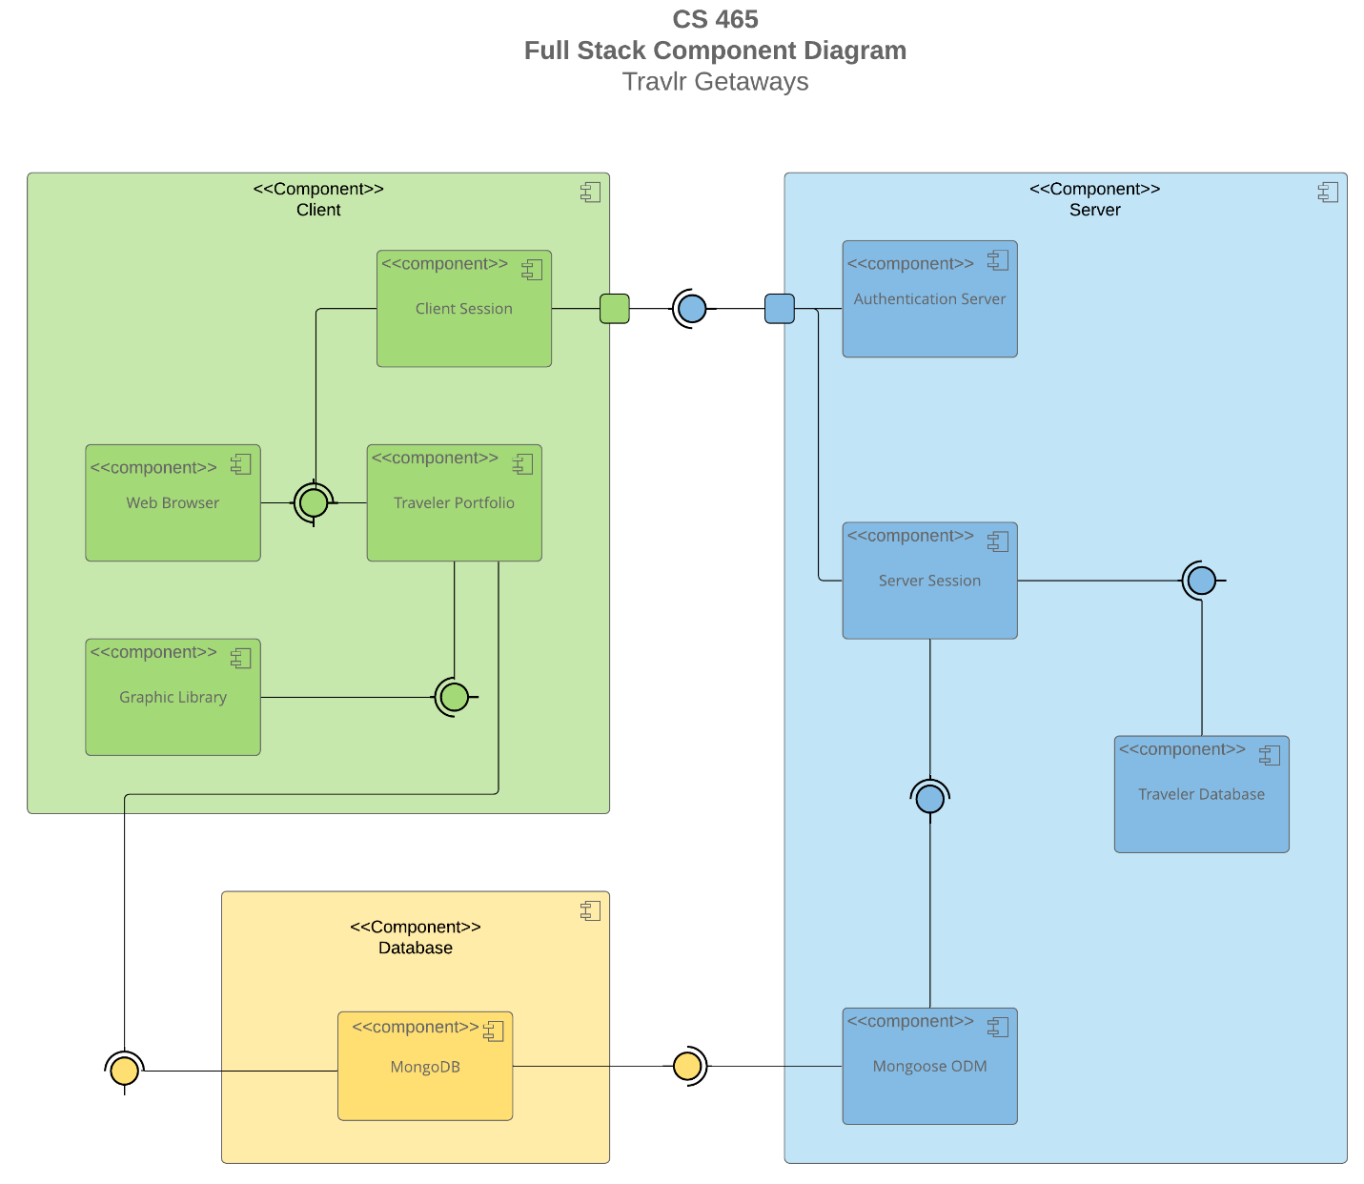

A text version of the component diagram is available: CS 465 Full Stack Component Diagram Text Version.

The Travlr Getaways application follows a three-tier MEAN stack architecture split into client, server, and database layers. On the client side, the Web Browser interacts with the Traveler Portfolio (the User’s profile) and Client Session, which manages user activity like browsing trips, logging in, and booking. The Graphic Library supports the UI with reusable visual components.

The client communicates with the server layer through the Client Session to Server Session connection, which handles all request/response flow. The Authentication Server is tied into this process to validate logins and secure access, especially for admin functionality. The Server Session acts as the core controller, routing requests and connecting to the Traveler Database logic via Mongoose ODM, which translates application data into database operations.

At the data layer, MongoDB stores all persistent data (users, trips, bookings, pricing, etc.). It doesn’t talk to the client directly; instead, everything flows through Mongoose and the server, keeping things structured and secure.

This separation of data and user logic keeps the client interface performant, the admin SPA secure and data storage and management abstracted.

Sequence Diagram

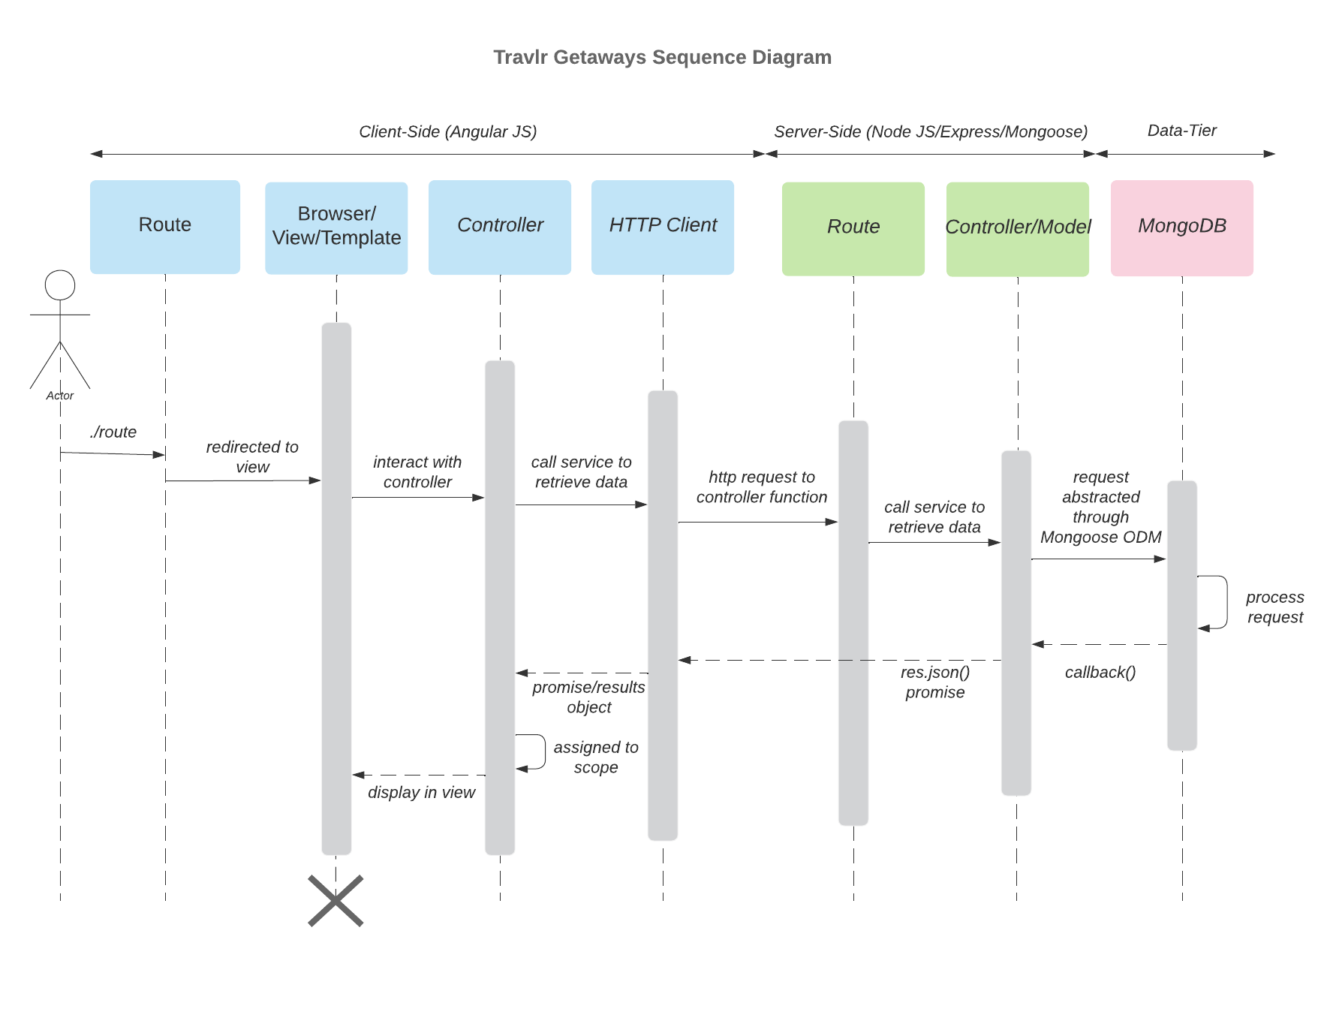

The sequence diagram illustrates how data flows through the Travlr Getaways application across the client, server, and database layers. The Angular admin SPA sends HTTP requests through Express routes, which serve as the central entry point to the backend system. Because the admin interface has elevated privileges over shared application data, it is protected with additional authentication and secured endpoints.

On the client side, the application logic (Angular components) requests data from the server. The Express route directs the request to the appropriate controller, which uses Mongoose to interact with MongoDB. After the database processes the request, the server returns the results as a JSON response. The Angular client then uses this data to update the view and display the requested content dynamically.

Class Diagram

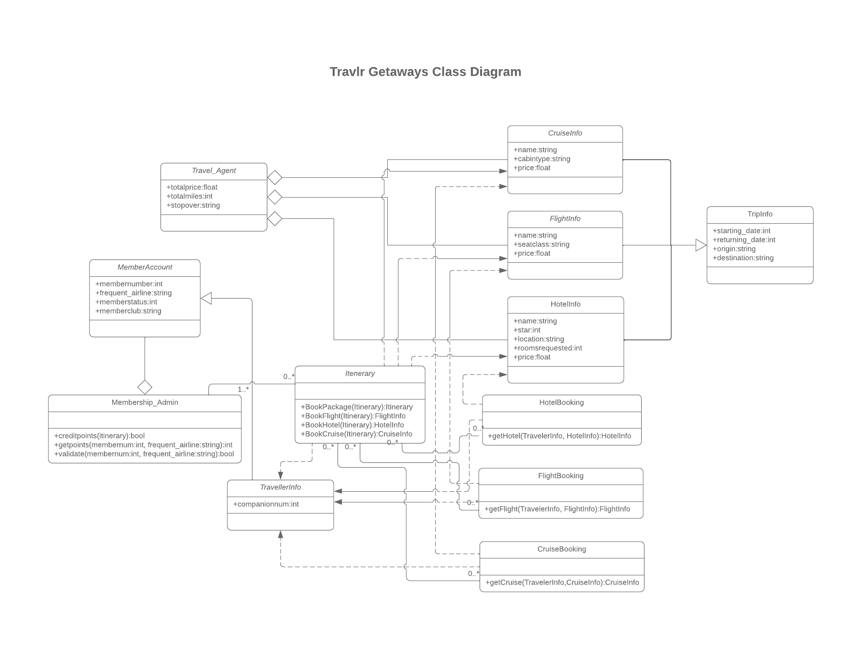

This diagram shows the class structure of the booking app. We see the Travel_Agent primitive class which holds data like the total trip price, miles and stopovers. From here we can see that CruiseInfo, FlightInfo and HotelInfo all extend Travel_Agent with other pertinent data like hotel room number or plane seat. All trip information is combined to create a TripInfo object. The Itinerary class is responsible for booking relevant flights, hotels and cruises using the Booking helpers. The MemberAccount class holds each member’s unique data like member number, favorite airline and club status. The MemberAccount data can only be edited by the Membership_Admin class by authorized users. The TravellerInfo class allows the Travel_Agent to add multiple MemberAccounts to a Booking.

API Endpoints

These RESTful endpoints allow both the admin SPA and user-facing website to integrate with the backend and database system built using MongoDB (via Mongoose), Express and Node.js. This includes endpoints for the secure authentication used in login, data modification and new account creation. Furthermore, all PUT and DELETE actions as well as any POST actions which modify data require administrator JWT authorization. Creating a new user is one exception to this, as anyone should be allowed to create a new, non-admin account. At this time all authenticated accounts are given admin access.

Method | Purpose | URL | Notes
POST | Login | /api/login | Authenticates the user’s credentials and returns an authentication token (JWT).
POST | Create User Account | /api/register | Registers a new user in the database.
GET | Get list of trips | /api/trips | Returns all active trips.
GET | Get a single trip | /api/trips/:tripCode | Returns a single trip based on the unique tripCode.
PUT | Update a trip | /api/trips/:tripCode | Updates an existing trip. (JWT)
POST | Add a new trip | /api/trips | Adds a new trip entry to the database. (JWT)
DELETE | Removes a trip | /api/trips/:tripCode | Deletes a trip from the database. (JWT)
GET | Get list of rooms | /api/rooms | Returns all active rooms.
GET | Get a single room | /api/rooms/:roomCode | Returns a single room based on the unique roomCode.
GET | Get list of meals | /api/meals | Returns all active meals.
GET | Get a single meal | /api/meals/:mealCode | Returns a single meal based on the unique mealCode.

The User Interface
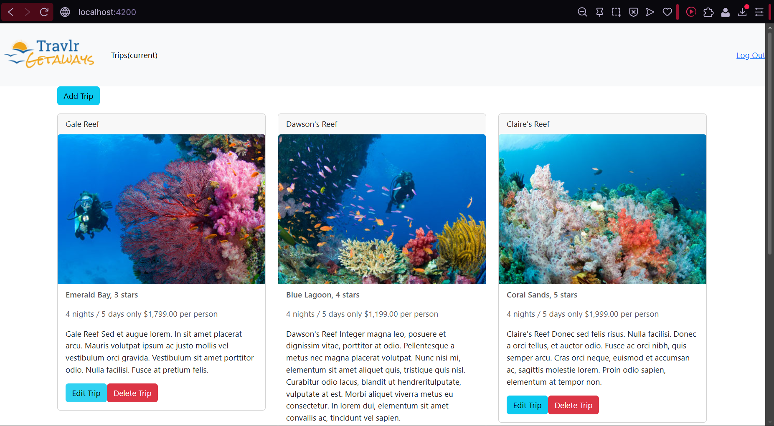
The SPA interface, while logged in. Shows the Add Trip button, array of trip cards (each with an Edit and Delete button), and the Log Out link in the navbar.

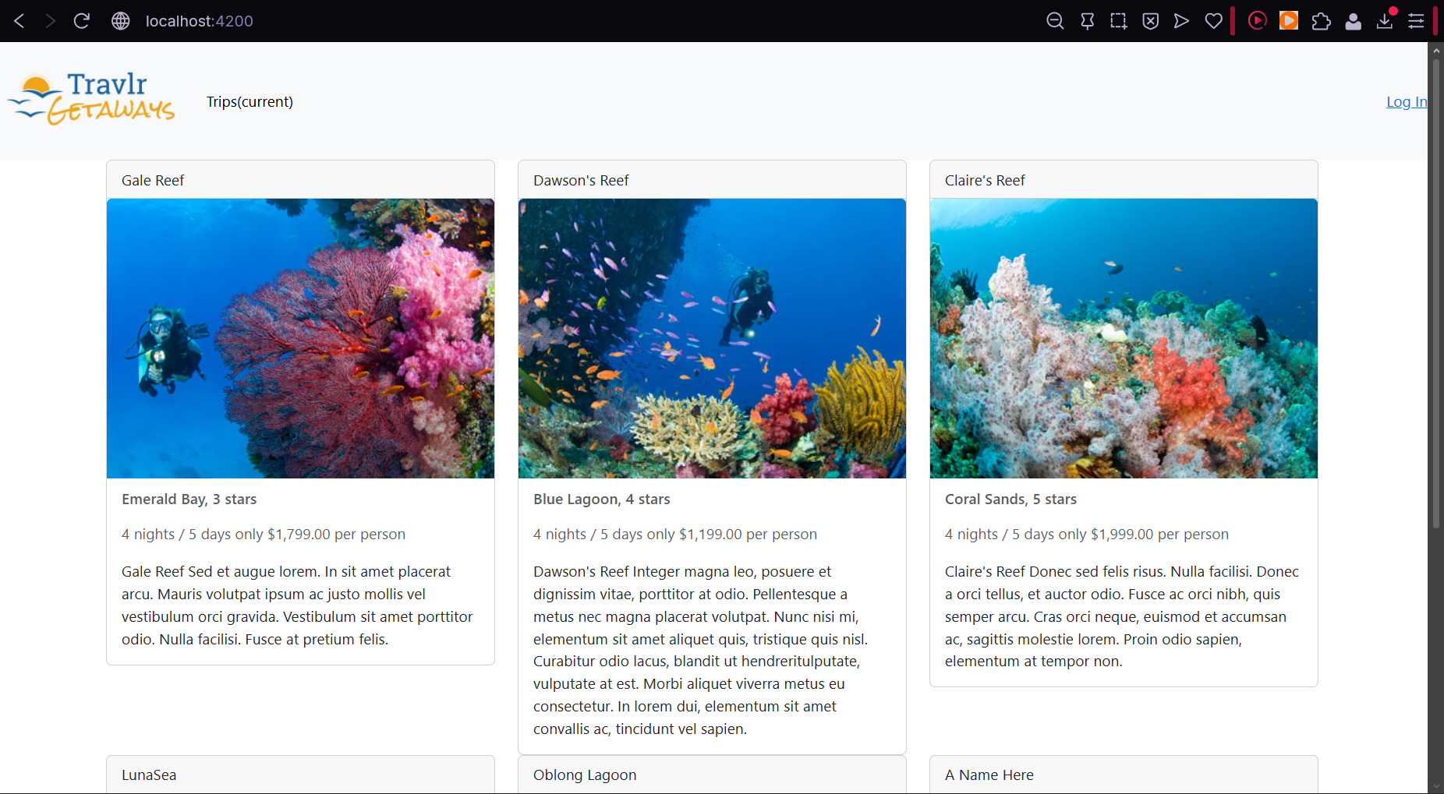
This is a shot of the SPA as it appears for a user who is not logged in (does not have CRUD privileges). The Log Out option is now a Log In option, leading to the next screen.

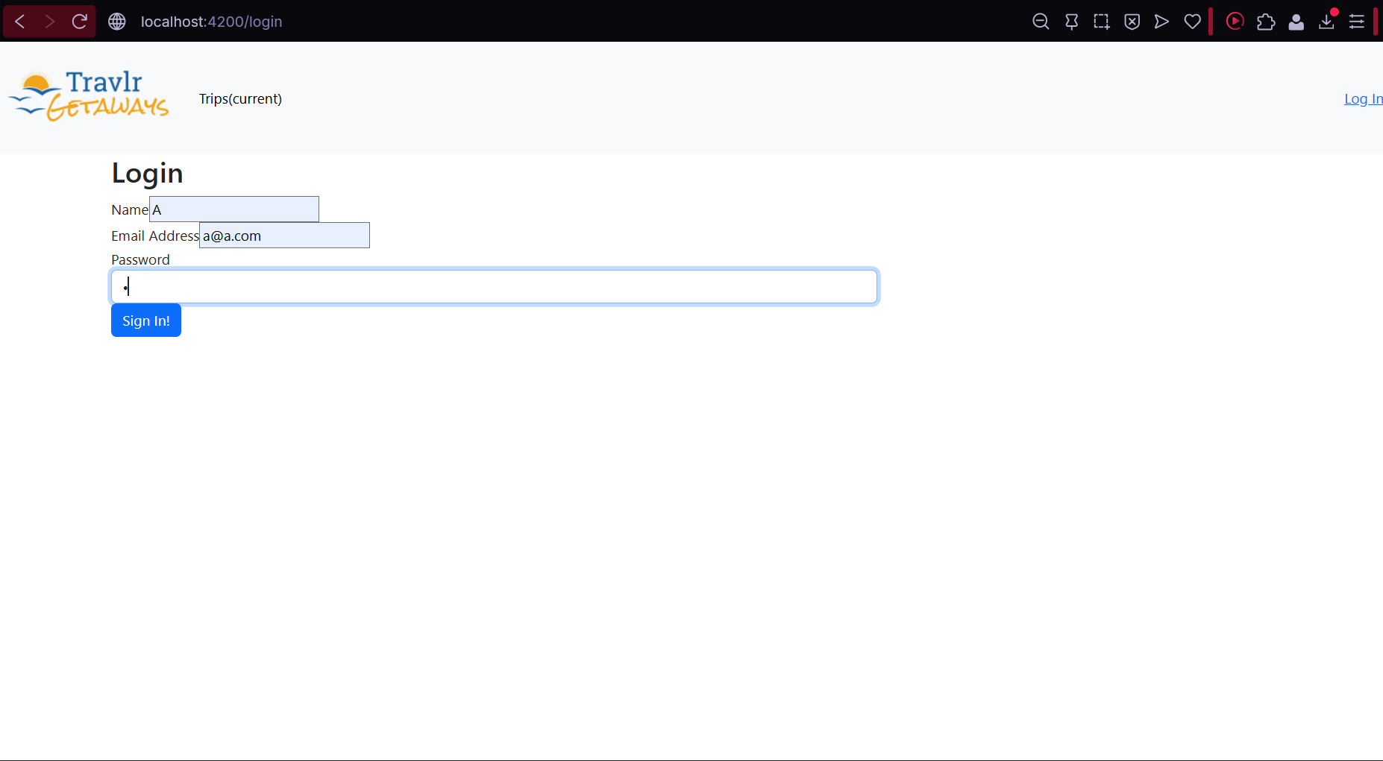
This is the login screen, which has fields for a username, email address and a password. All three fields must be validated in order to log in.

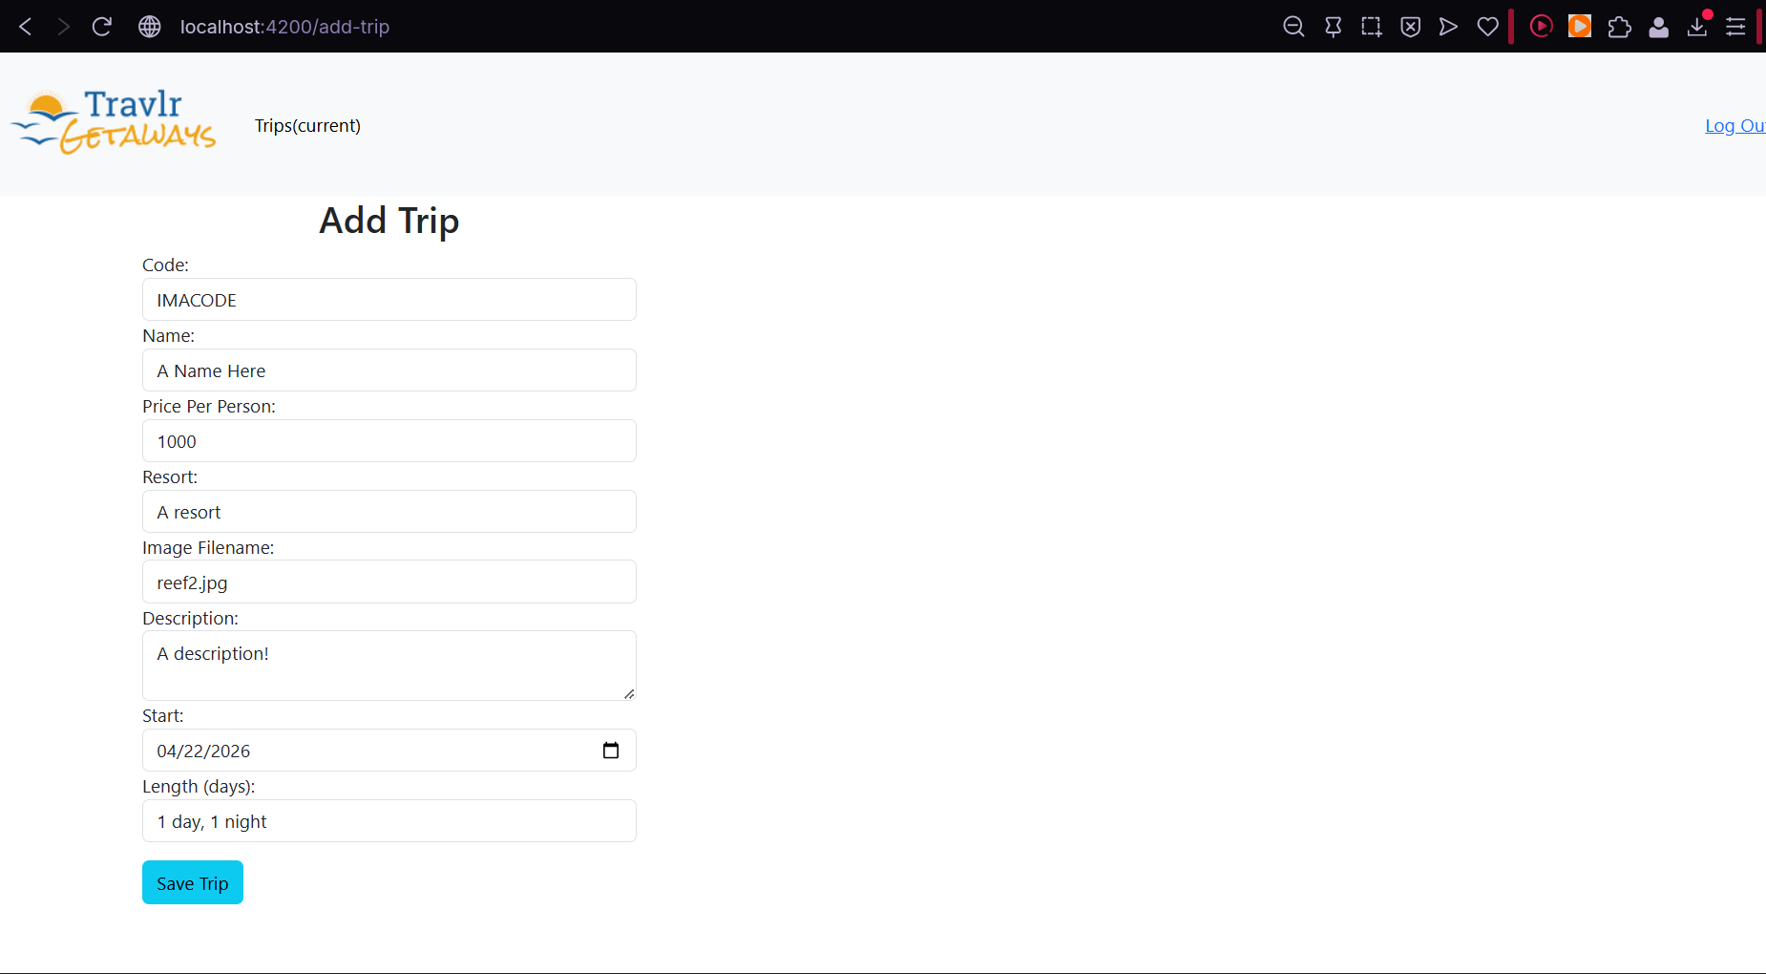
Logged-in users can add new trips via this screen. All fields must be filled in order to add a trip.

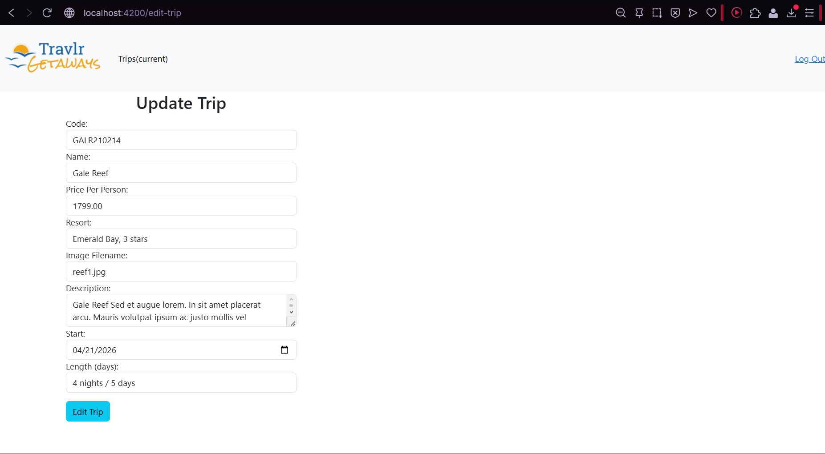
Likewise, logged-in users can update existing trips.

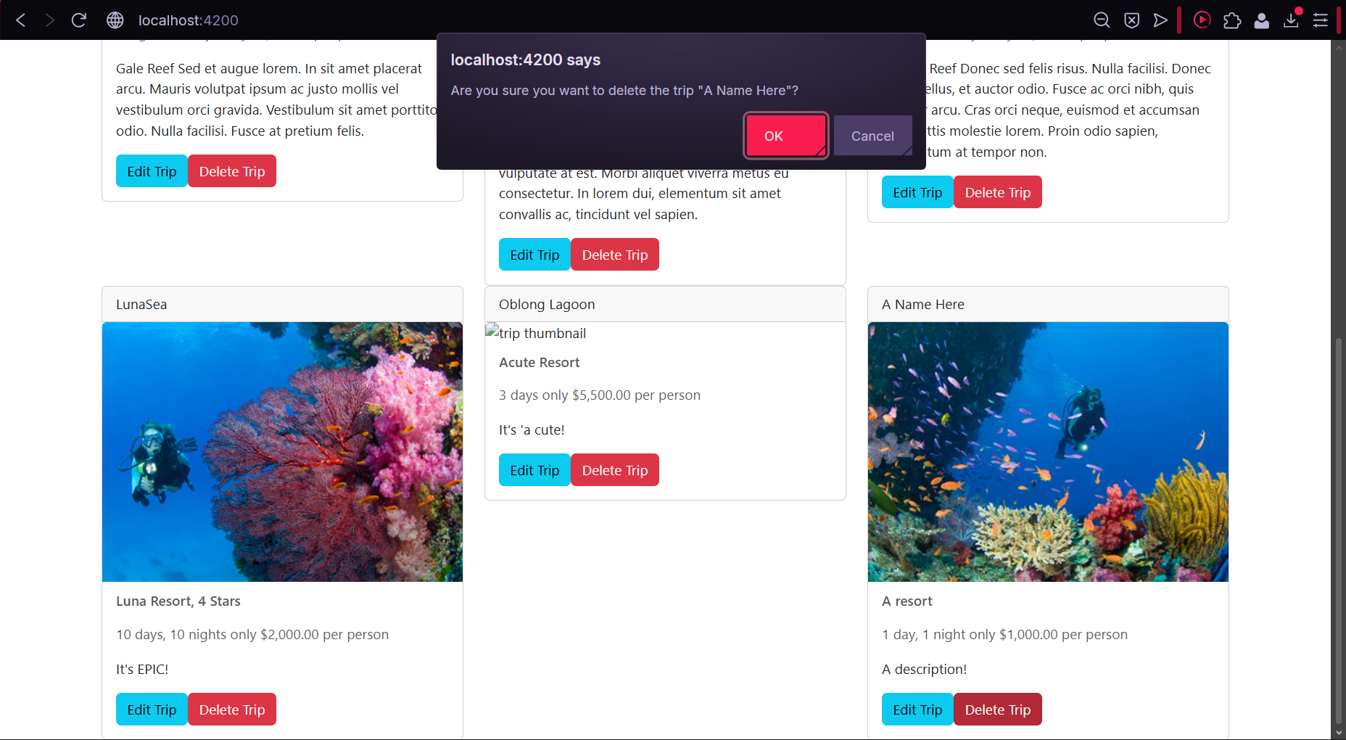
When clicking ‘Delete Trip’ a popup confirmation window appears which repeats the selected trip’s name to prevent accidental deletions.

SPA Summary

The Angular project structure is component-based and organized around reusable UI elements, routing, services, and models. Angular components manage the layout and interaction of the administrator interface, while shared services handle communication with the Express API. This differs from the Express customer-facing project structure, which follows a more traditional MVC pattern using routes, controllers, and Handlebars views to render pages on the server. The SPA provides richer interactivity because it can dynamically update the interface without requiring full page reloads, making tasks like viewing, editing, and deleting trips faster and more responsive. To test the SPA, API endpoints were first verified independently, then the Angular interface was used to confirm that GET requests correctly loaded trip data from MongoDB and that PUT requests successfully updated existing records in the database and refreshed the displayed results.

